View | Description
Logical | The system needs to have the following functionality:  - The host/hostess must be able to view which tables are available for seating.  - The system must allow orders to be entered into it.  - The system must forward the above-mentioned orders to the kitchen staff.  - The kitchen staff must be able to notify the appropriate wait staff when the order is ready through the system.  - The system must track the times a customer is seated, the time they order, the time their order is ready and the time they leave.  - The system must save all receipts.  - Bus boys must be able to view which tables need to be cleared.  - Management must be able to view all restaurant related information on the system.  - *highlights are actors and classes.  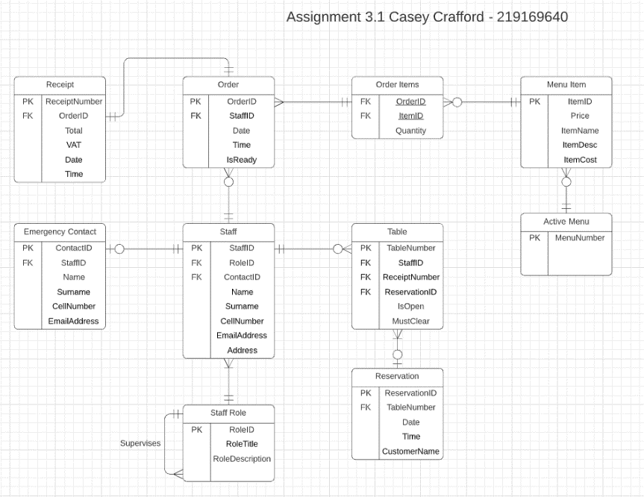  Key Artifacts: ERD :  Stakeholders:
Process | The system will be able to run tasks in a parallel fashion, meaning it will be able to execute two or more tasks simultaneously (e.g., A waiter enters an order while a host request for available tables). This system UI will also be able to run on lower-end devices, so that the restaurant can use tablets for ordering but do not need to spend excessive amounts of money on these tablets. Stakeholders include the developers, the software engineers and the end users as they will be affected by the performance of the system.  Key Artifacts include the sequence diagram:  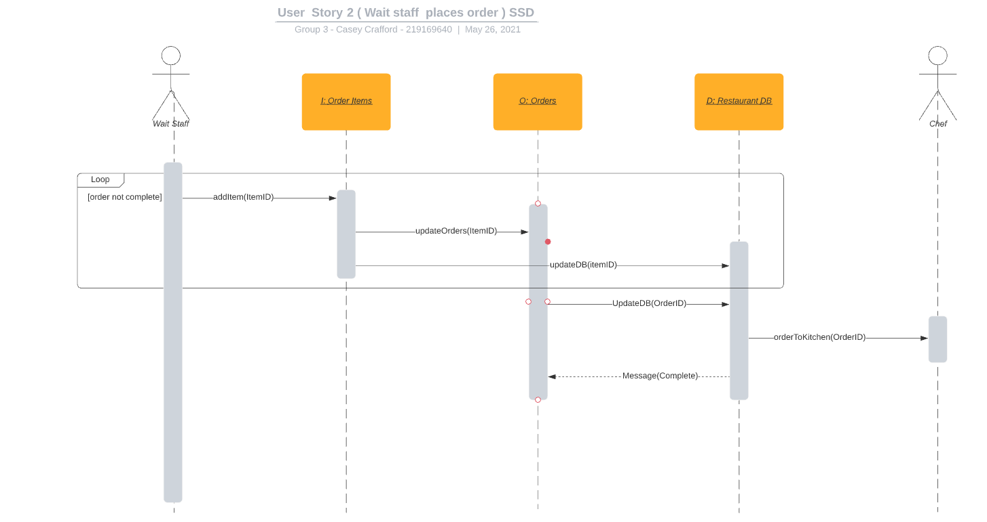
Development | This project can be divided into a few main areas: device UI, database creation and application code. The device UI entails creating the UI which the end users will interact with. The database creation entails creating the MySQL database that will store and process all the information of the restaurant. The application code involves the back-end required for the end-user program, this involves creating all the required classes and methods required for the program to run.  The stakeholders in this view are mainly the developers and software managers as they will be using this to determine which teams/individuals will be responsible for certain areas of code. Key artifacts include a component diagram.
Physical | The physical architecture involved with this project includes tablets, a central server, a computer, and screens. The tablets will be used by waiters and waitresses for taking in orders, hosts and hostesses for viewing available tables, and by bus boys for viewing tables that need to be cleared. The central server will store all the information for the restaurant, it does not need to be a physical server and can be a cloud server which the restaurant pays monthly for. The computer will be used by management and the desktop application will have more functionality for this reason. The screen(s) are for the kitchen staff who will be able to see current and incoming orders.  Stakeholders include the system engineers and key artifacts include the deployment diagram.
Scenario | The system needs to provide the following for its users:  - The host/hostess must be able to view which tables are available for seating.  - The system must allow orders to be entered into it.  - The system must forward the above-mentioned orders to the kitchen staff.  - The kitchen staff must be able to notify the appropriate wait staff when the order is ready through the system.  - The system must track the times a customer is seated, the time they order, the time their order is ready and the time they leave.  - The system must save all receipts.  - Bus boys must be able to view which tables need to be cleared.  - Management must be able to view all restaurant related information on the system.  The stakeholders here are the end users because this view shows what they will use the system for.  Key artifacts are user stories as seen above and use case diagrams as below:  